|  |  |
| --- | --- |
| **Soal Praktikum**  *Practicum Case* |  |
| ISYS6169 /T0206  Database System |
| **Sistem Informasi**  *Information System* | **E1-ISYS6169-AM01** |
| **Periode Berlaku** Semester Ganjil 2016/2017  ***Valid on*** *Odd Semester Year 2016/2017* | **Revisi 00**  *Revision 00* |

**Learning Outcomes**

* Apply database language and SQL Programming language
* Evaluate database processing and security Mechanism

## Topic

* Session 08 **-** SQL –Data Definition (2)

## Sub Topics

* Create and Update View
* Dropping Views
* **Access control : GRANT and REVOKE command**

**Tabel Relasional**

*Relational Table*

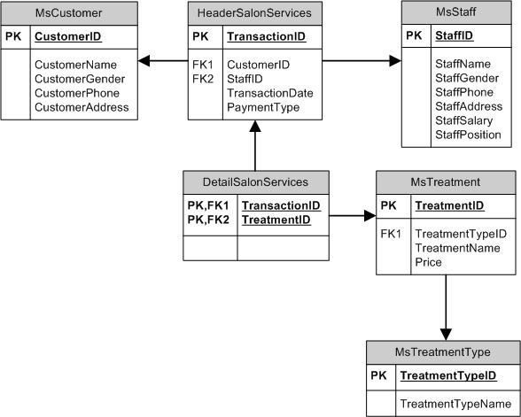

**Sintaks**

*Syntax*

**GRANT**  
GRANT { ALL [ PRIVILEGES ] }

| permission [ ( column [ ,...n ] ) ] [ ,...n ]

[ ON [ class :: ] securable ] TO principal [ ,...n ]

[ WITH GRANT OPTION ] [ AS principal ]

**REVOKE**  
REVOKE [ GRANT OPTION FOR ]

{

[ ALL [ PRIVILEGES ] ]

|

permission [ ( column [ ,...n ] ) ] [ ,...n ]

}

[ ON [ class :: ] securable ]

{ TO | FROM } principal [ ,...n ]

[ CASCADE] [ AS principal ]

**CREATE USER**  
CREATE USER user_name

[

{ FOR | FROM } LOGIN login_name

]

[ WITH DEFAULT_SCHEMA = schema_name ]

[ ; ]

**DROP USER**

DROP USER user_name

## Soal

*Case*

1. Create login named ‘ManagerUser’.

(**create login**)

1. Create user named ‘Manager’ for ManagerUser login.

(**create user**)

1. Create login named ‘EmployeeUser’.

(**create login**)

1. Create user named ‘Employee’ for EmployeeUser login.

(**create user**)

1. Remove update privilege on **MsStaff** table from Manager.

(**revoke**)

1. Give all privileges on **MsTreatment** table to public.

(**grant**)

1. Give insert, update, delete privileges to Manager on **MsStaff** table and the manager can give privilege to another user.

(**grant**, **with grant option**)

1. Give select privilege on **MsTreatmentType** table to Manager.

(**grant**, **to**)

1. Remove all privileges on **MsTreatment** table from public.

(**revoke**)

1. Remove update privilege on **MsStaff** table from Manager.

(**revoke**)